**Learn how to create hyperlinks and display images on a webpage using HTML.**

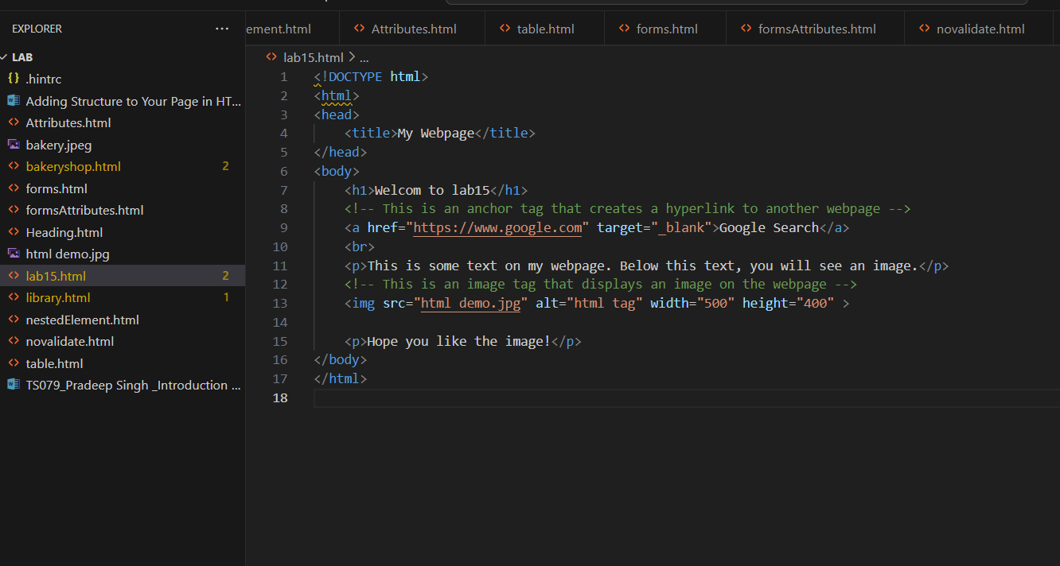



**Output screen will look like as below:**

